EtherChannel creates an aggregation that is seen as one logical link => redundancy
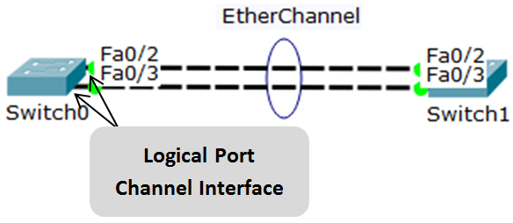
Usually each EtherChannel can consist of up to 8 compatibly-configured Ethernet ports.
Cisco IOS switch can usually supports 6 EtherChannels.
- all physical links in the EtherChannel are active because STP sees only one logical link.
- the loss of one physical link within the channel does not create a change in the topology => a spanning-tree recalculation is not required
- the spanning-tree cost is calculated based on the number of ports assigned to the port-channel and it does not dynamically change when links go down or are brought back up within the port-channel
- If the physical ports of one side are configured as trunks, the physical ports of the other side must also be configured as trunks within the same native VLAN
Protocols:
- Port Aggregation Protocol (PAgP)
- Link Aggregation Control Protocol (LACP)

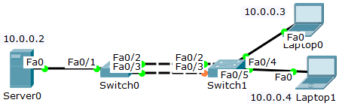
Examine and explain the output of this command.
Switch0#show spanning-tree

Switch0(config)#interface range fastEthernet 0/2-3
Specify the interfaces that compose the EtherChannel group

Switch0(config-if-range)#channel-group 1 mode on
Create the port channel interface 1

Switch0#show etherchannel summary
View the Etherchannel information with the

Switch0(config)#interface port-channel 1
Switch0(config-if)#switchport mode trunk
Configure the EtherChannel as a trunk interface

Switch0(config)#port-channel load-balance dst-mac
Configure EtherChannel load balancing method

Switch0#show etherchannel load-balance
View the EtherChannel load balancing method information

